Classic Cookbooks for your mini kitchen

Quarter Inch Scale. These books are all about 9 inches high in real life.

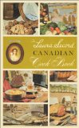 | 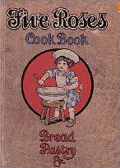 | 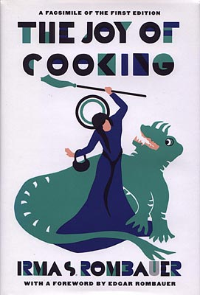
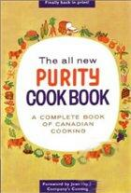 | 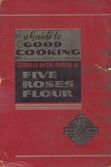 | 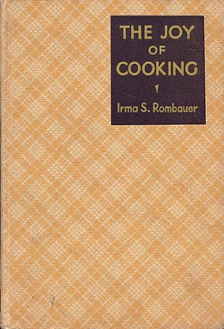
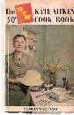 | 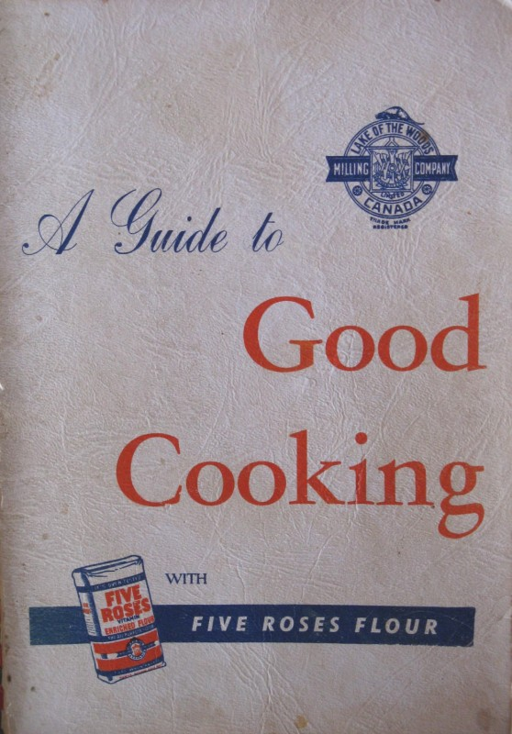 | 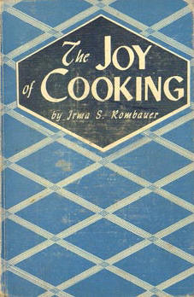
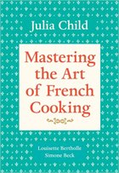 | 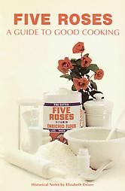 | 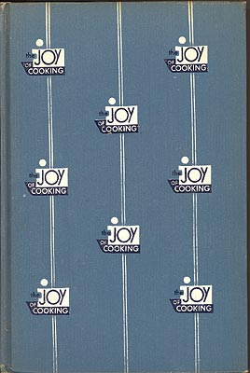
 | 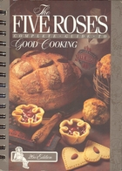 | 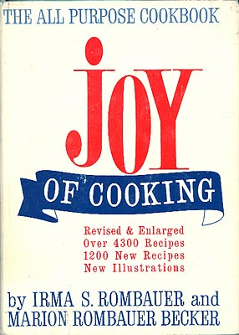
 |  | 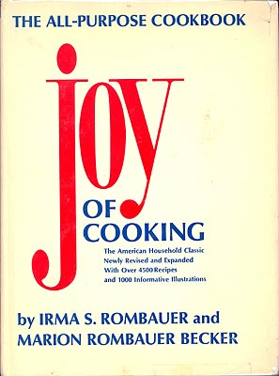
 | 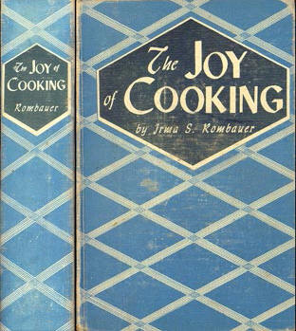

1 inch books. 0.8 in height (most of them) makes them just over the real height of 9 inches

Laura Secord Canadian Cookbook, 1967 |  | Purity Cookbook 1967 |  | Julia Child – Mastering the art of French Cooking (date?) |  | Kate Aitken 1953 |  | Five Roses Flour Guide to Good Cooking
 |  |  |  |  |  |  |  | ca 1915 |  | 1930s | ca 1950 |  | ca 1970 |  | 1980s?
 |  |  |  |  |  |  |  |  |  |  |  | 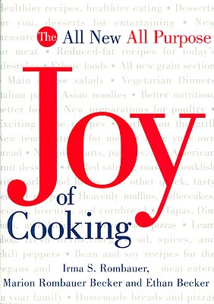 |  | 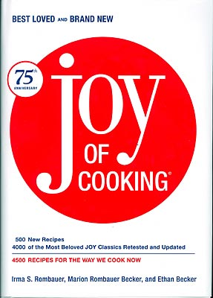
1931 | 1936 |  | 1943-46 |  | 1951 |  | 1963 |  | 1975 |  |  | 1997 |  | 2006

